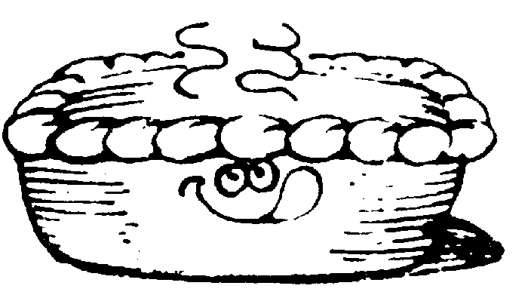MOONEE VALLEY CRICKET CLUB

PIE DRIVE

We have organised with Tony’s Pies of Essendon to conduct a Pie Drive.
Tony’s Pie’s will supply us with a range of their freshly baked pies, pasties, quiches and sausage rolls on Tuesday, 11th of March.

All the products will be freshly baked and will be suitable to go straight into the freezer if you wish.

So order up BIG. Remember, the more you order the more we make. Make your choice from the list below and return your order with the correct money or cheque by Tuesday, 4th of March.

We need the support of everyone to make this fundraising a success.

Product  Per ½ Dozen | Qty | Price  Per ½ Dozen | Total | Product  Family Size. | Qty | Price  Each | Total
Chunky Steak |  | $24.00 |  | Chunky Steak |  | $10.00
Steak & Mushroom |  | $26.00 |  | Steak & Mushroom |  | $11.00
Steak & Bacon |  | $26.00 |  | Steak & Bacon |  | $11.00
Steak & Cheese |  | $26.00 |  | Steak & Cheese |  | $11.00
Bacon, Tomato & Cheese Quiche |  | $26.00 |  | Bacon,Tomato & Cheese Quiche |  | $10.00
Spinach, Onion & Cheese Quiche |  | $26.00 |  | Spinach, Onion & Cheese Quiche |  | $10.00
Pasties |  | $24.00 |  | Pasties |  | $10.00
Sausage rolls |  | $14.00 |  | Apple Pie |  | $8.00
Party Pies |  | $7.00 |  | Blueberry Pie |  | $8.00
Spinach & Cheese Rolls |  | $20.00
Lasagna Rolls |  | $20.00
Apple Pies |  | $24.00
Blueberry Pies |  | $24.00
Sub Totals

Total: $.................... Group:.....................................

Name:....................................................... Phone:....................................

Please Make Cheques Payable to “Moonee Valley Cricket Club”

