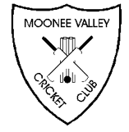
Presents…

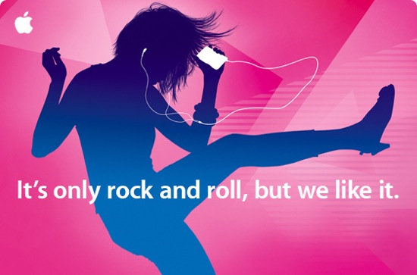

(Run as a reverse auction)
Saturday 22nd February
Begins 7:30pm

$25 for pre-listed song
with a runtime under 5 minutes
A free beer when your song plays
$30 for pre-listed song
with a runtime over 5 minutes
A free beer & shot when your song plays
$35 to pick your own song
A free beer & shot when your song plays

PRIZES
First: $150
Second: $75
Third: 10x Drink Card

First Song Played: 5x Drink Card

