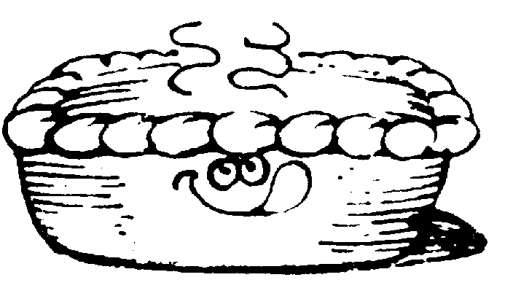MOONEE VALLEY CRICKET CLUB

PIE DRIVE

We have organised with Tony’s Pies of Essendon to conduct a Pie Drive.
Tony’s Pie’s will supply us with a range of their freshly baked pies, pasties, quiches and sausage rolls on Tuesday, 20th of October.

All the products will be freshly baked and will be suitable to go straight into the freezer if you wish.

So order up BIG. Remember, the more you order the more we make. Make your choice from the list below and return your order to the Club with the correct money, cheque or electronic payment by Tuesday, 13th of October. *****Drop the order into our Ormond Park clubrooms or email to charlie.walker@optusnet.com.au

We need the support of everyone to make this fundraising a success.

Product  Per ½ Dozen | Qty | Price  Per ½ Dozen | Total | Product  Family Size. | Qty | Price  Each | Total
Chunky Steak |  | $25.00 |  | Chunky Steak |  | $11.00
Steak & Mushroom |  | $26.00 |  | Steak & Mushroom |  | $12.00
Steak & Bacon |  | $26.00 |  | Steak & Bacon |  | $12.00
Steak Tomato & Onion |  | $26.00 |  | Steak Tomato & Onion |  | $12.00
Bacon, Tomato & Cheese Quiche |  | $26.00 |  | Bacon,Tomato & Cheese Quiche |  | $11.00
Spinach, Onion & Cheese Quiche |  | $26.00 |  | Spinach, Onion & Cheese Quiche |  | $11.00
Pasties |  | $25.00 |  | Pasties |  | $11.00
Sausage rolls |  | $15.00 |  | Apple Pie |  | $9.00
Party Pies |  | $7.00 |  | Blueberry Pie |  | $9.00
Spinach & Cheese Rolls |  | $20.00
Lasagna Rolls |  | $20.00
Apple Pies |  | $25.00
Blueberry Pies |  | $25.00
Sub Totals

Total: $.................... Group:.....................................

Name:....................................................... Phone:....................................

Please Make Cheques Payable to “Moonee Valley Cricket Club",
pay via the EFTPOS machine at the clubrooms or make a direct deposit to our account – BSB 633 108, a/c No. 138449160 – and make sure you include your name in the information field

